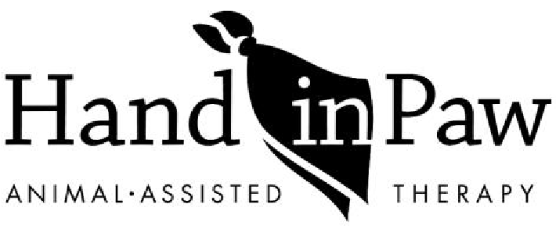

VIRTUAL VISIT APPLICATION

Hand in Paw places great priority on the health and wellbeing of our volunteer teams, clients, and program partners and are committed to the highest standards in the Animal Assisted Therapy field. We are offering Virtual Visits while our teams are unable to visit in the community due to COVID-19. Hand in Paw Teams are dedicated to maintaining a positive connection to our community by boosting morale and providing stress relief.

- ZOOM Video Conferencing is required for a HIP virtual visit
- Length of visit: each visit will last 15- 30 minutes
- Number of teams: to be determined based on volunteer team availability

Organization Name: ________________________________________________________________________________

Physical Address: _______________________________________City/State____________________Zip_____________

Contact Name: _________________________________________ Title: ______________________________________

Telephone/Cell: _________________________________________E-mail: ____________________________________

Date of Virtual Visit: | Start time and end time:
Anticipated Guest Count:

Please describe in detail the goal of therapy team visit:

Additional notes/instructions:

Internal Use Only
One- time visit □ or recurring □
Program area:
Advanced or non □
Teams recruited via TW □ or email □
Teams:
Supervision:
Zoom invite created

Please submit your application to Director of Volunteers and Programs, Kiersten Atkinson, via e-mail.
Email: kiersten@handinpaw.org

