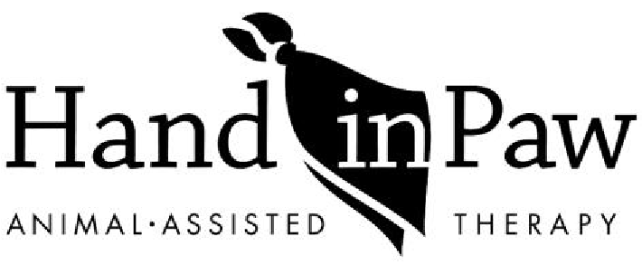
617 38th Street South
Birmingham, AL 35222
P 205.322.5144 F 205.322.7784
www.handinpaw.org

ONE TIME VISIT APPLICATION
Thank you for your interest in having Hand in Paw therapy teams visit your organization!
Hand in Paw relies on teams of volunteers to fulfill visit requests. We do our best do accommodate requests, however, a therapy team visit is not guaranteed. Please note the following:

- Notice: application request must be submitted a minimum of 4 weeks prior to visit/event
- Length of visit: each visit will last 1- 1.5 hours long
- Number of teams: to be determined based on team availability and number of attendees at event
- No other animals are permitted during visit. HIP’s liability insurance is not valid when non-Hand in Paw animals are present.

Facility/Organization Name:
Type of facility/organization: (school, college, business etc.)
Physical Address:
City/State: | Zip
Telephone:
Contact Person: | Contact Title:
Contact Telephone: | Contact e-mail:

Date of Visit/Event: | Start and end time of visit event:
Description of visit/event: (will take place in one large room, outdoors, etc.)

Description of population you serve: (age, demographics, challenges)

Approximate number of people to be seen:

Please describe in detail the goal of therapy team visit:

Additional notes/instructions:

Please submit your application to Program Coordinator, Tripp Windham, via fax or e-mail.
Fax: 205.322.7784
Email: tripp@handinpaw.org

