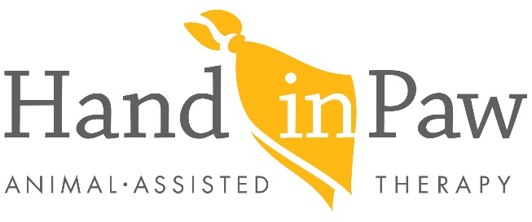

Volunteer Roadmap

General Requirements before taking the next steps to becoming a Hand in Paw Therapy Team:
Animal must be 18 months old
You must have lived with your animal for 6 months
You and your dog must complete a group obedience class
Animal must have up to date rabies and vaccinations

- Complete online Volunteer Application
- Attend Community Open House Info Session
- Submit Rabies Certificate and Group Obedience Course Certificate to:
Volunteer Coordinator Stacey Roudebush: stacey@handinpaw.org
- Schedule interview/pet screening with Hand in Paw
Please bring the following forms to the interview/evaluation:
- Completed Handler’s Questionnaire
- Towel or blanket for small dogs or cat (10- 15 pounds is considered small)
- Collar and leash must be leather or fabric, no prong collars or retractable/metal leashes
- Complete one Shadow Visit (without your pet)
- Observe Hand in Paw Therapy Team in action
- Complete Hand in Paw Therapy Team Workshop Sessions
- Workshop sessions are held once a week for 4 weeks
- Each session is ~2 hours
- $50.00 fee is due at the first workshop to cover the cost of workshop materials
- Complete Practice Evaluation
- This is your opportunity to practice for the Final Evaluation
- Complete Final Evaluation
- $75.00 registration fee due when evaluation is complete
- Registration fee includes cost of liability insurance, lifetime membership fee for *ITA, visit backpack, and Hand in Paw gold polo shirt
- Attend New Team Orientation
- You and your pet attend a 1 hour new team orientation at HIP to review important procedures to begin your Hand in Paw Therapy Team visits

*ITA- Hand in Paw is an affiliate of Intermountain Therapy Animals. Intermountain Therapy Animals sets the standard for force- free training, positive reinforcement and relationship- building in the training, handling and the care of animals.

Rev. 12.20.2019

