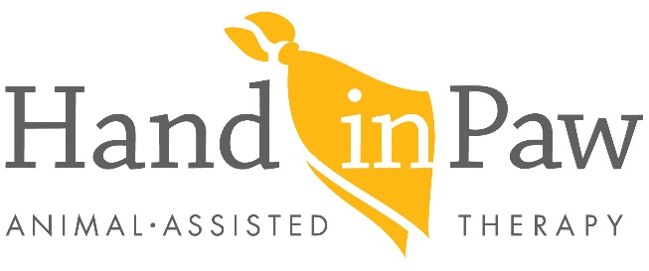

Volunteer Roadmap

General Requirements before taking the next steps to becoming a Hand in Paw Therapy Team:
Animal must be 2 years old
You must have lived with your animal for 6 months
You and your dog must complete a group obedience course
Animal must have up to date rabies and vaccinations
Handler must have COVID vaccine

- Complete online Volunteer Application
- Submit Rabies Certificate, Group Obedience Course Certificate, and COVID card to:
Volunteer Coordinator Stephanie Stoltzner: stephanie@handinpaw.org
- Schedule interview/pet screening with Hand in Paw
Please bring the following forms to the interview/evaluation:
- Towel or blanket for small dogs or cat (10- 15 pounds is considered small)
- Collar and leash must be leather or fabric, no prong collars or retractable/metal leashes
- Complete Hand in Paw Therapy Team Workshop Sessions
- Workshop sessions are held once a week for 4 weeks
- Each session is ~2 hours
- Complete Practice Evaluation
- This is your opportunity to practice for the Final Evaluation
- Complete Final Evaluation
- The evaluation gives you an opportunity to demonstrate your team skills. Our Evaluators will guide you through a series of exercises that show the connection you share with your dog and their willingness to follow your cues.
- Complete Two Shadow Visits (without your pet)
• Observe Hand in Paw Therapy Team in action
- Attend New Team Orientation
• You and your pet attend a 1 hour new team orientation at HIP to review important procedures to begin your Hand in Paw Therapy Team visits

*ITA- Hand in Paw is an affiliate of Intermountain Therapy Animals. Intermountain Therapy Animals sets the standard for force- free training, positive reinforcement and relationship- building in the training, handling and the care of animals.

Rev. 4.6.2023

