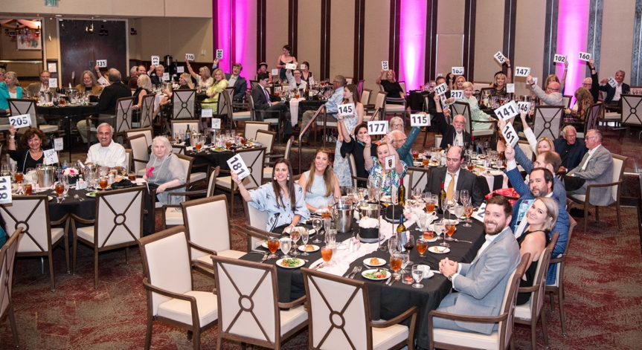
FOR IMMEDIATE RELEASE
August 30, 2023

CONTACT:
Brittany Filby, Director of Communications
205.322.5144x160
brittany@handinpaw.org

Hand in Paw’s 22nd Annual Picasso Pets Gala Exceeds Fundraising Goal

Birmingham, AL: At the 22nd Annual Picasso Pets gala Presented by VP Funds, Hand in Paw supporters united to help people in need experience the power of Animal-Assisted Therapy, exceeding the nonprofits fundraising goal. Picasso Pets is Hand in Paw’s largest single source of revenue and ensures that their services can be delivered free of charge.

Picasso Pets took place on August 19th at The Harbert Center in downtown Birmingham. This year’s gala was especially meaningful as 2023 is “The Year of Picasso”, which marks the 50th anniversary of the death of Pablo Picasso. Picasso’s life was full of dogs, they were his life and muse, and he often hid them in corners of paintings and depicted them in his signature modernist style. To celebrate this special year, Hand in Paw displayed vintage Picasso Pets paintings that featured dachshunds, Picasso’s favorite breed.

The gala included a cocktail reception that featured a new-and-improved photo booth experience, a live auction with many unique, can’t-get-anywhere-else items, and a delicious seated dinner. Throughout the event, guests enjoyed sipping on signature Tito’s Handmade Vodka cocktails, meeting Hand in Paw Therapy Teams, and listening to heartfelt testimonials. Dr. Jim and Katie Lasker presented the Tweety Lasker Award to Oak Mountain Elementary School, which is awarded each year to an organization that partners with Hand in Paw to serve the community with excellence.

One of the evening's most anticipated moments was getting to see the completed Picasso Pets paintings which were made by pets belonging to prominent members of the community with help from well-known local artists. The commission from these unique paintings are donated to Hand in Paw to help strengthen and expand its services. This year’s presenters were Ken Jackson, Carter and Jessica McLean, and Ann Hemphill. This year’s artists were Linda Ellen Price, Thomas Andrew, and Carol Carmichael.

The 2023 Faces of Picasso Pets were Pippa, Bernie and Borris Davis. The adorable furry trio are the pets of long-time Hand in Paw supporters and Creative Dog Training’s Founder and CFO, Margaret and Conor Davis. The theme for the night was “tutus and top hats” and guests were encouraged to wear top hats and tulle to match!

Executive Director, Margaret Stinnett, states “Picasso Pets is the highlight of our summer! We were thrilled to see over 250 people who appreciate the mission of Hand in Paw and understand the power of Animal-Assisted Therapy. My favorite part of the evening is the parade of our Therapy Teams around the ballroom. These dogs and people are our heroes, volunteering countless hours throughout the year to serve the most vulnerable in our community. Volunteering for Hand in Paw is a unique opportunity to work with your pet. The best advice I know for a day you are feeling a little blue, “Feeling down? Go help someone. Reach out.” The joy and happiness our volunteers receive, through giving is why Hand in Paw is celebrating 27 years of service. Want to add joy to your life – consider volunteering with Hand in Paw!”

Emcee: Lisa McNair • Sponsorship Chair: Melanie Lewis • Auctioneers: Trip Cobb and David Gibert • Title Sponsor: VP Funds • Stage Sponsor: Tito’s Handmade Vodka • Tweety Lasker Sponsor: Dr. Jim & Katie Lasker • VIP Room Sponsor: Mr. & Mrs. Scott Vowell • Petcasso Exhibit Sponsor: Medical Properties Trust • Photo Booth Sponsor: John 3:16

###

ABOUT HAND IN PAW
With a mission to improve human health & well-being, Hand in Paw is Alabama’s premier Animal-Assisted Therapy provider and a national leader in this growing field. Hand in Paw’s professionally trained volunteer handler and animal Therapy Teams help improve people’s day to day lives in several medical centers, schools, and human service organizations throughout North Central Alabama and Tuscaloosa. Our volunteer teams make thousands of beneficial visits through community events and participating facilities each year, helping countless children with special needs, at-risk youth, struggling students, and people with chronic and terminal illnesses. At no time has Hand in Paw charged for its services. For more information, visit www.handinpaw.org.

