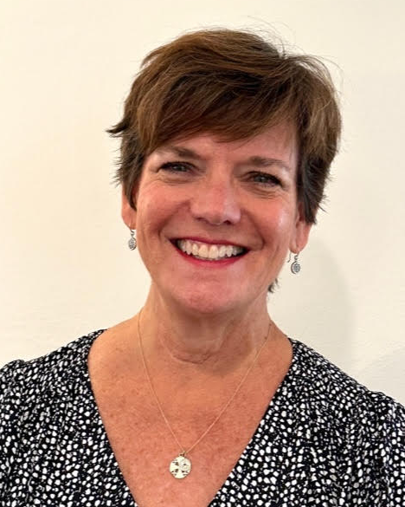
FOR IMMEDIATE RELEASE
October 17, 2023

CONTACT:
Brittany Filby, Director of Communications
205.322.5144x160
brittany@handinpaw.org

Hand in Paw Welcomes Caroline Bundy as Director of Development

Birmingham, AL – (October 17, 2023) Hand in Paw, a Birmingham nonprofit with a mission to improve human health and well-being through Animal-Assisted Therapy, is pleased to announce the appointment of Caroline Bundy as its new Director of Development.

With over 13 years of experience in the nonprofit sector, Caroline joins Hand in Paw with an impressive track record, most recently serving as the Director of Development at AIDS Alabama. Her deep-rooted passion for community service, wealth of development experience, and love for animals have made her a valuable addition to the organization.

In her new role, Caroline will lead Hand in Paw’s Development Department, where her responsibilities will encompass growing fundraising events and cultivating and nurturing relationships with supporters, volunteers, and the community at large.

Caroline brings not only her professional expertise but also her extensive network of contacts within the Greater Birmingham community, which will further the reach and services that Hand in Paw provides in the state.

“Just meeting Caroline sparks joy. Hand in Paw is so fortunate to have her join our team! Alongside our Founder, Beth Franklin and working closely with our Communications Director, Brittany Filby, I know that Caroline will help lead us into a bright future.”

Caroline Bundy's appointment is a significant step forward for Hand in Paw as the organization continues to grow and make a profound difference in the lives of individuals through the power of Animal-Assisted Therapy.

For more information about Hand in Paw and its mission, please visit handinpaw.org

###

ABOUT HAND IN PAW
With a mission to improve human health & well-being, Hand in Paw is Alabama’s premier Animal-Assisted Therapy provider and a national leader in this growing field. Hand in Paw’s professionally trained volunteer handler and animal Therapy Teams help improve people’s day to day lives in several medical centers, schools, and human service organizations throughout North Central Alabama and Tuscaloosa. Our volunteer teams make thousands of beneficial visits through community events and participating facilities each year, helping countless children with special needs, at-risk youth, struggling students, and people with chronic and terminal illnesses. At no time has Hand in Paw charged for its services. For more information, visit www.handinpaw.org.

