
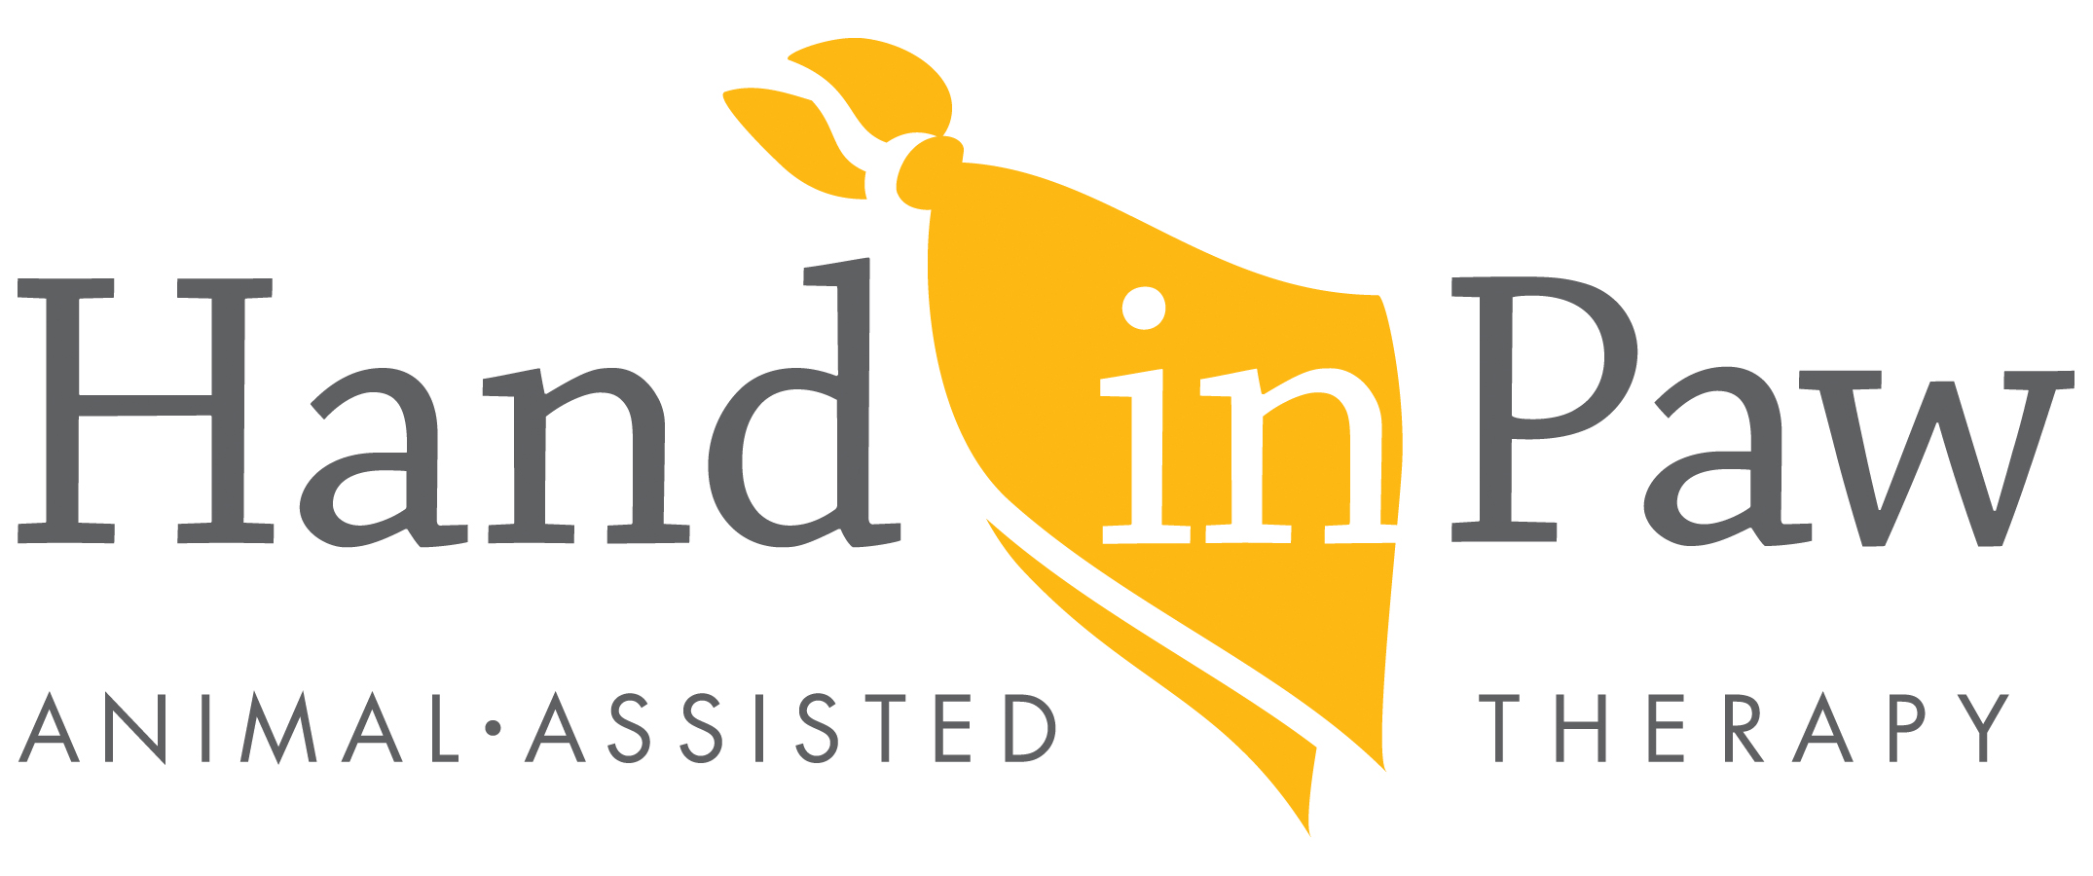

FOR IMMEDIATE RELEASE
March 13, 2024

CONTACT:
Brittany Filby, Director of Communications
205.322.5144x160 brittany@handinpaw.org

Lace Up Your Boogie Shoes for Mutt Strut
Presented by BluePearl Specialty + Emergency Pet Hospital

Birmingham, AL: Hand in Paw’s 14th Annual Mutt Strut: Dog-Friendly 5k and 1 Mile Fun Run presented by BluePearl Specialty + Emergency Pet Hospital will take place at Homewood Central Park April 20th, 2024! Runners and walkers of all skill levels are encouraged to join the furry fun for the whole family – all while supporting a wonderful cause!

This year’s Mutt Strut will feature a disco theme, promising a morning filled with funky beats, dazzling disco outfits, and wagging tails as the community comes together to raise funds for Hand in Paw. The event will kick off with a non-chipped 5k run followed by a 1-mile fun run, ensuring that there’s something for everyone, from seasoned runners to casual walkers.

Registration for the 5k costs $30, while the fun run is $25. Included in the race registration is a race t-shirt and matching doggie bandana, entry into award categories, and the opportunity to visit with local vendors and enjoy family-friendly fun in the Mutt Strut Vendor Village.

But Mutt Strut isn’t just about the races – it’s a day filled with entertainment and activities for all ages. Families can enjoy our Kids Zone, featuring a giant bubble creation station, face painting, and the opportunity to meet and play with adoptable pets from the Greater Birmingham Humane Society. Plus, attendees can look forward to an amazing dance performance by local disco group, Magic City Disco, and a unique photo opportunity provided by Magic City in Motion.

Mutt Strut registration and Vendor Village opens at 7:30am with the races starting at 9am. The Awards Ceremony will be held onsite after the race at 10:30am. To keep the party going, Good Dog Park & Bar will be hosting an afterparty for Mutt Strut attendees from 11-2pm. Entry to the afterparty is free for runners and will feature live music, food trucks, and a kid’s area.

Brittany Filby, Hand in Paw’s Communications Director, states, “We’re thrilled to bring back Mutt Strut for another year of fun and fundraising. This event is not only a great way to get active with your furry friends, but also an opportunity to support our mission of spreading love and healing through the power of therapy animals.”

Mutt Strut is hosted by Hand in Paw’s Junior Board and supports the Animal-Assisted Therapy nonprofit. Hand in Paw’s professionally trained teams of animals and handlers provide comfort and joy at local medical centers, schools, and human service agencies free of charge. Money raised at this event makes it possible for Hand in Paw to continue to positively impact the lives of countless people dealing with emotional and physical life challenges across North Central Alabama and Tuscaloosa.

Registration for Mutt Strut is now open, and participants can sign up online at www.handinpaw.org/muttstrut or register in person on the day of the event. For more information about Mutt Strut or to inquire about vendor opportunities, please contact Amanda Summers at amanda@handinpaw.org. For sponsorship opportunities, please contact Caroline Bundy at caroline@handinpaw.org

Mutt Strut would not be possible without our Gold sponsors: UAB Medicine, Susan and Rick Nelms in Memory of Christopher, ABC 3340, 23 Design, and Bham Now.

###
ABOUT HAND IN PAW
With a mission to improve human health & well-being, Hand in Paw is Alabama’s premier Animal-Assisted Therapy provider and a national leader in this growing field. Hand in Paw’s professionally-trained volunteer handler and animal Therapy Teams help improve people’s day to day lives in several medical centers, schools, and human service organizations throughout North Central Alabama and Tuscaloosa. Our volunteer teams make thousands of beneficial visits through community events and participating facilities each year, helping countless children with special needs, at-risk youth, struggling students, and people with chronic and terminal illnesses. At no time has Hand in Paw charged for its services. For more information, visit www.handinpaw.org.

